**Frontend Development with React.js**

**Project Documentation: A4 News App**

**1. Introduction**

**Project Title:**

A4 News App

**Team Members and Roles:**

**Team Leader**: Abinaya. M

**Email ID**: sac2225cap06@ssacollegechennai.com

**Team Members:**

* **Abinaya K L**

**Email ID**: klabinaya17kalaiselvan@gmail.com

* **Aarthi R**

**Email ID**: sac2225cap04@ssacollegechennai.com

* **Arthi. G**

**Email ID**: aarthigs19@gmail.com

**2. Project Overview**

**Purpose:**

A4 News is a web application designed to enhance the way users consume news by offering a seamless, interactive experience. It aggregates news from multiple sources, categorizes content, and provides an advanced search feature for easy navigation.

**Features:**

* Aggregated News from API sources.
* Intuitive and user-friendly interface.
* Powerful search functionality.
* Visually engaging design with categorized news display.
* Subscription feature for daily news updates.

**3. Architecture**

**Component Structure:**

The project follows a modular React.js component structure:

* Pages Folder: Contains different application pages.
* Components Folder: Stores reusable UI elements.
* Context Folder: Manages application state using Context API.
* Styles Folder: Stores CSS files for styling.

**State Management:**

Uses Context API for global state management and local state handling within components.

**Routing:**

Implemented using React Router Dom for smooth navigation between pages.

**4. Setup Instructions**

**Prerequisites:**

Node.js and npm (Download: <https://nodejs.org/en/download>)

Git for version control (Download: <https://git-scm.com/downloads>)

**Installation:**

git clone repository link

1. Clone the repository:

cd news-app

2. Install dependencies:

npm install

3. Start the development server:

npm start

## 4. Folder Structure

nexus-news/  
│── src/  
│ ├── components/   
│ ├── context/   
│ ├── pages/   
│ ├── styles/   
│── public/  
│── package.json  
│── README.md

**6. Running the Application**

**Run the frontend server:**  
  
npm start  
  
Access the app at http://localhost:3000

**7. Component Documentation**

* Navbar: Displays navigation links.
* Hero Section: Highlights trending news.
* NewsCard: Displays individual news articles.

**8. State Management**

* Global State: Managed using Context API.
* Local State: Controlled within individual components.

**9. User Interface**

Screenshots:

* Hero section showcasing trending news

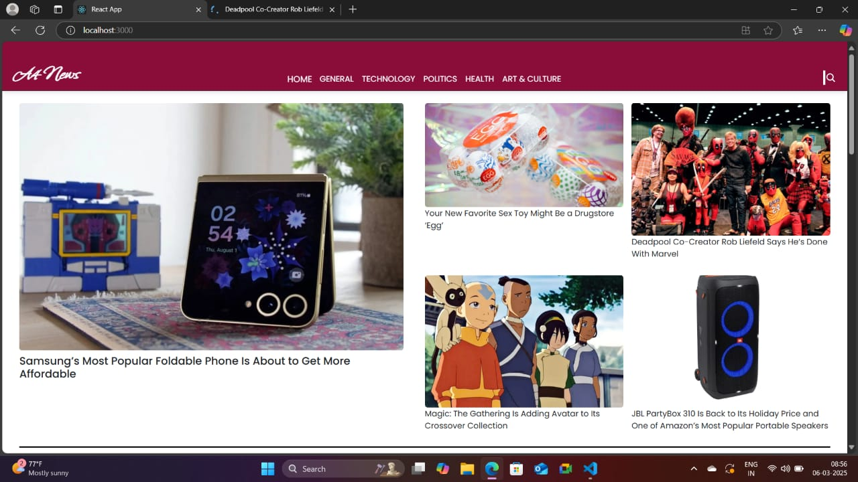

* Category search results page.

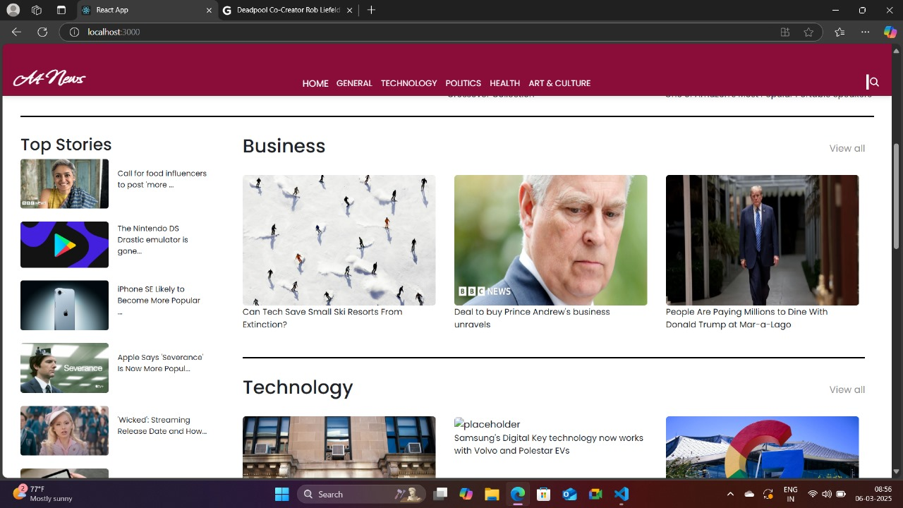

**10. Styling**

* Bootstrap/Tailwind CSS used for UI design.
* React Icons for visual elements.

**11. Testing**

* Jest & React Testing Library used for unit and integration testing.

**12. Screenshots or Demo**

* **Hero component**



* **Redirected component:**

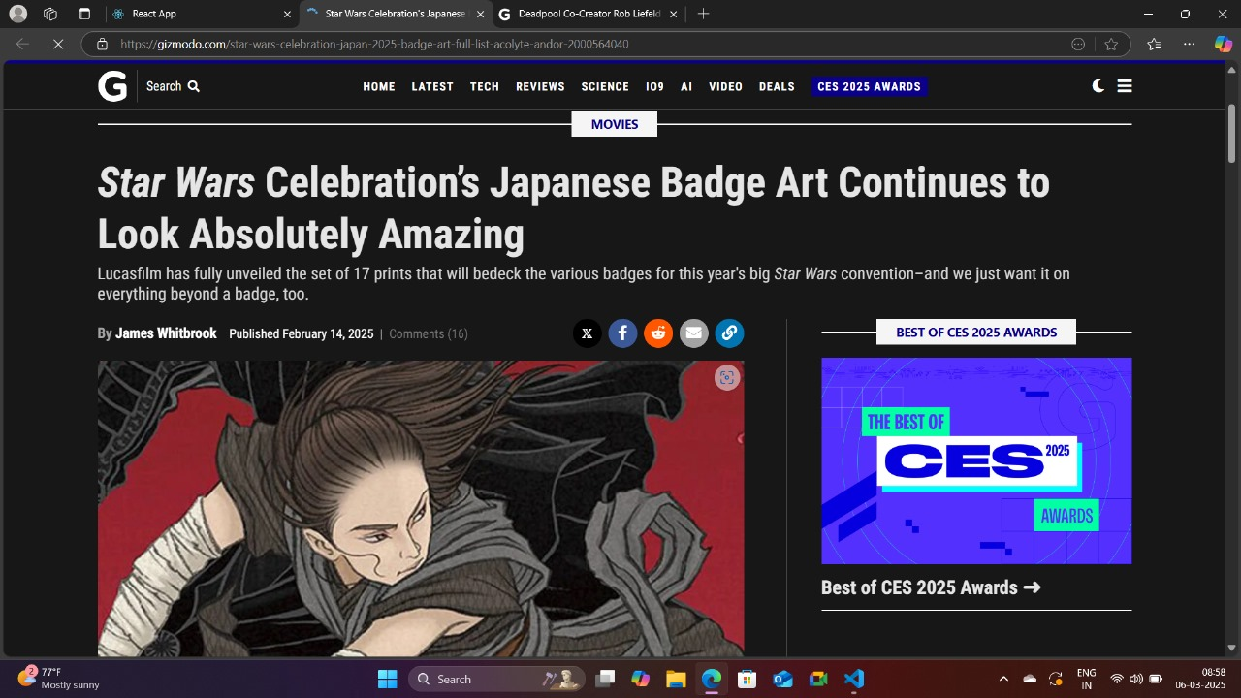

* **Category component**



* **News Letter:**

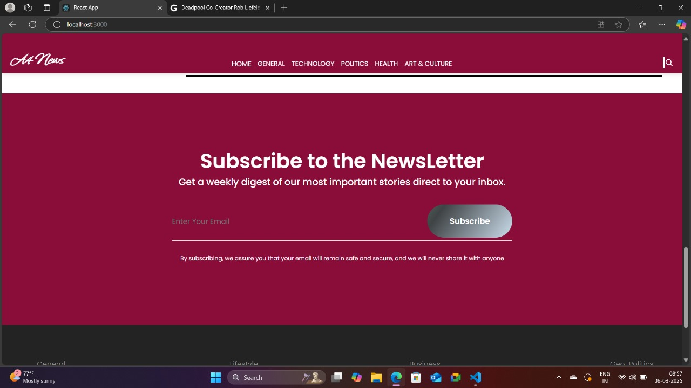

Live Demo:

[https://drive.google.com/file/d/1MkW7l5o72dZLm7b79ox5DIsgzWOEfCCP/view?usp=sharing](https://drive.google.com/file/d/1MN-gX1HM8RnPp85DJV44f6AdlGcUO9yV/view?usp=drive_link)

**13. Known Issues**

* Some API calls may have rate limits.
* UI improvements needed for better mobile responsiveness.

**14. Future Enhancements**

* User Authentication
* Push Notifications
* Dark Mode

**15. Code Repository**

Use the source code link: [https://drive.google.com/file/d/1MXxIYN5fDLYYec4SVnw9-L3ZNd-z3rhg/view?usp=drive_link](https://drive.google.com/file/d/1MXxIYN5fDLYYec4SVnw9-L3ZNd-z3rhg/view?usp=drive_link%20)

Thank you!